Strengths-Based 101
Supplemental Handouts

Youth In Need, Inc.
What’s Your Story? Getting to Know You

- I applied for a position at Youth In Need because: _____________________
___________________________________________________________________
___________________________________________________________________
___________________________________________________________________
___________________________________________________________________

- One thing I knew about Youth In Need going into my interview was: ________
___________________________________________________________________
___________________________________________________________________

- One thing that excites me about working at Youth In Need is: _____________
___________________________________________________________________
___________________________________________________________________

- One potential challenge in my job is: ___________________________________
___________________________________________________________________
___________________________________________________________________

- Qualities of mine that can help me to face challenges I may encounter in my job:
_________________________ _________________________
_________________________ _________________________
_________________________ _________________________
_________________________ _________________________

- If I face a challenges or adversity in my job I will: ________________________
___________________________________________________________________
___________________________________________________________________

- My supervisor and coworkers can help me to grow and meet present and future

challenges by: ___________________________________________________
___________________________________________________________________
___________________________________________________________________

- Youth In Need can best support me by: _____________________________
___________________________________________________________________
___________________________________________________________________

- I can support Youth In Need by: _____________________________________
___________________________________________________________________
___________________________________________________________________

- My personal motto: ________________________________________________
___________________________________________________________________
___________________________________________________________________

What Does Evidence-Based Mean?
The point of being evidence-based is to ensure that our practices have a valid scientific basis, are delivered by a provider who is skilled, open, and responsive to feedback, and with consideration to the client and his or her culture and preferences. Below are three definitions of “evidence-based,” which share the above commonalities.

(1) American Psychological Association (APA): “The integration of the best available research with clinical expertise in the context of patient characteristics, culture, and preferences.”
(2) Institute of Medicine (IOM): “Evidence based medicine is the conscientious, explicit, and judicious use of current best evidence in making decisions about the care of individual patients. The practice of evidence based medicine means integrating individual clinical expertise with the best available external clinical evidence from systematic research.”
(3) Substance Abuse Mental Health Services Administration (SAMHSA): “EBPs integrate clinical expertise; expert opinion; external scientific evidence; and client, patient, and caregiver perspectives so that providers can offer high-quality services that reflect the interests, values, needs, and choices of the individuals served.”

Sources:
(1) APA Presidential Task Force on Evidence-Based Practice. (2006). Evidence-based practice in
psychology. American Psychologist, 61(4), 271–285.
(2) Sackett, D. L., Rosenberg, W. M. C., Muir Gray, J. A., Haynes, R. B., & Richardson, W. S. (1996).
Evidence based medicine: What it is and what it isn't: It's about integrating individual clinical expertise and the best external evidence. BMJ: British Medical Journal, 312(7023), 71-72.
(3) SAMHSA. (2016, January 6). Evidence-based practices web guide.
https://www.samhsa.gov/ebp-web-Guide
A Model for Evidenced-Based Practice (EBP)

ASSESS
Start with the client–a problem or question arises from services for the client.
ASK
Construct a well-built question derived from the client situation.
ACQUIRE
Select the appropriate resource(s) to review or search.
APPRAISE
Appraise that evidence for its validity (closeness to the truth) and applicability (usefulness in practice).
APPLY
Return to the client–integrate that evidence with expertise, client preferences, and apply it to practice.
EVALUATION
Evaluate your performance with this client and the impact of services. Incorporate client feedback.
RESPOND
Respond to feedback about progress in the form of improvement, no change, or deterioration.

Characteristics of Effective Behavioral Health Care and Social Services Providers
1. The ability to feel at ease and comfortable with other people, especially young people: Someone who is relaxed and not threatened by personal interaction.
2. The ability to put others, especially young people at ease: Someone others just naturally open up to, quickly.
3. The ability to project unconditional regard and acceptance of others: Someone who is genuinely nonjudgmental or who can appear to be so.
4. The ability to convey warmth and empathy: Someone who projects understanding of others' feelings and thoughts.
5. Good verbal and interpersonal skills: Someone who gets along well in many different situations and with many different kinds of people and who can use language to seem like one of the group.
6. Good listening skills: Someone who pays close attention to what others say and does not feel compelled to always inject personal thoughts and comments into the conversation.
7. The ability to project enthusiasm: Someone who seems genuinely interested in others and whose enthusiasm engages the interest of others.
8. An awareness of one's own nonverbal reactions: Someone who is capable of maintaining body language and facial expressions that project the above traits and does not convey annoyance or frustration.
9. Physical characteristics that are non-threatening, intimidating, or off-putting to others.
10. The ability to conceptualize and to think through complex situations as opposed to thinking literally and in a rote manner.

Strengths-Based vs. Non-Strengths-Based
Strengths-Based | Non-Strengths-Based
- Recognition of the youth as having abilities and strengths.  - Recognition of the youth’s caregivers as competent and caring. | - Presumption of the youth as lacking in ability and having deficits.  - Presumption of incapability by caregivers.
- Appreciation that caution toward professionals, if present, may be an appropriate response to past experience. | - Regarding caution as "resistance," lack of readiness, or character-based hostility.
- Recognition of the primary expertise of caregivers, who are full partners in treatment, in relation to their child. | - Caregivers seen as obstacles to treatment, or as entirely dependent on the expertise of professionals.
- Recognition of children and adolescents as resilient, with desire for approval from adults, and capacity to make choices of their own. | - Children/adolescents seen as fragile or unreachable and unable to make meaningful personal decisions.
- Mental health, other human service professionals and educators seen as offering essential experience and willingness to collaborate. | - Other professionals seen as part of the problem, or as pursuing own agenda (saving money, avoiding responsibility, etc.).
- Recognition that every child's/adolescent’s community contains valuable resources to be tapped. | - Certain communities seen as entirely negative without countervailing resources.
- Recognition that effective treatment involves intrinsic (non-professional) resources, not just professional services. | - Continuing dependence on services and professionals to produce change.
- Recognition that specific racial and cultural factors influence the treatment process and that the child's cultural heritage and practices need to be understood and respected. | - Belief that "everyone is the same," and that good intentions without awareness of culture is sufficient.
- Commitment to a multi-level understanding of the child, encompassing the child, family, community, helping systems, culture. | - Belief that understanding of single dimension(s) is enough (e.g., biological, emotional, family, etc.)
- Commitment to consensus building among key participants as essential to effective treatment and service determination. | - Belief that experts alone are best equipped to make clinical decisions, and that involvement of other will hinder the process.
- Belief that meaningful change is attainable; problems are barriers to progress, not fixed pathology. | - Problems seen as result of regression, fixation and pathology. Tendency to fix blame.

Pathology vs. Strength-Based Vocabularies
Pathology-Based  Fix  Weakness  Limitation  Pathology  Problem  Insist  Closed  Shrink  Defense  Expert  Control  Backward  Manipulate  Fear  Cure  Stuck  Missing  Resist  Past  Hierarchical  Diagnose  Treat  End  Judge  Never  Limit  Defect  Rule | Strengths-Based  Empower  Strength  Possibility  Health  Solution  Invite  Open  Expand  Access  Partner  Nurture  Forward  Collaborate  Hope  Growth  Change  Latent  Utilize  Future  Horizontal  Appreciate  Facilitate  Beginning  Respect  Not yet  Expand  Asset  Exception

Pathology vs. Strengths-Based Conversations
Pathology-Based Conversations  Conversations for explanations  - Searching for evidence of functions for problems  - Searching for or encouraging searches for causes and giving or supporting messages about determinism (biological/developmental/psychological)  - Focusing or allowing a focus on history as the most relevant part of the youth’s life  - Engaging in conversations for determining diagnosis, categorization, and characterization  - Supporting or encouraging conversations for identifying pathology  Conversations for inability  - Searching predominantly or exclusively for what youth cannot do and lack in terms of skill or ability  Conversations for insight/understanding  - Focusing primarily or exclusively on insight  Conversations for expressions of emotion  - Focusing primarily or exclusively on elicitation of youth’s expressions of feelings and on feelings  Conversations for blame and recrimination  - Making attributions of bad/evil personality or bad/evil intentions  Adversarial conversations  - Believing that youth and/or caregivers or supportive others have hidden agendas that keep them from cooperating with treatment goals/methods  - Using trickery/deceit to get youth to change  - Believing that residential and other professional staff are experts and youth and caregivers or supportive others are nonexperts | Strengths-Based Conversations  Conversations for change/difference  - Highlighting changes that have occurred in youth’s problem situations  - Presuming change will and is happening  - Searching for descriptions of differences in the problem situation  - Introducing new distinctions or highlighting distinctions with youth  Conversations for competence/abilities  - Presuming youth competence/ability  - Searching for contexts of competence away from the problem situation  - Eliciting descriptions of exceptions to the problem or times when youth dealt with the problem situation in a way they liked  Conversations for possibilities  - Focusing the conversation on the possibilities of the future/goals/visions  - Introducing new possibilities for doing/viewing into the problem situation  Conversations for goals/results  - Focusing on how youth and caregivers or supportive others will know that they’ve achieved their therapeutic goals  Conversations for accountability/personal agency  - Holding youth and caregivers or supportive others accountable for their actions  - Presuming actions derive from youth’s intentions/selves  Conversations for actions/description  - Channeling the conversation about the problem situation into action descriptions  - Changing characterizational/theoretical talk into descriptive words  - Focusing on actions youth and caregivers or supportive others can take that make a difference in the problem situation

Strengths-Based Principles in Practice

1. Expectancy and Hope are Catalysts of Change
- Maintain the belief that clients are motivated and capable of proactive change.
- Demonstrate faith in clients and their caregivers to achieve positive change.
- Demonstrate faith in the restorative effects of services.
- Build on preservice expectancy (i.e., the expectations clients and others may have at the start of services).
- Create expectancy for change by focusing on what is possible and changeable.
- Create expectancy for change by using language that is respectful and emanates hope.
- Accommodate clients’ expectations of therapy.
- Believe and demonstrate faith in the procedures and practices utilized.
- Show interest in the results of the therapeutic procedure, orientation, or method.
- Ensure that the procedure or orientation is credible from the client’s or caregiver’s frame of reference.
- Ensure that the procedure or orientation is connected with or elicits the client’s previously successful experiences.
- Work in ways that enhance or highlight client’s feelings of personal control.
- View client as people, not as their problems or difficulties or in ways that depersonalize them.

2. Clients are the Most Significant Contributors to Service Success
- Communicate the belief that clients are competent and capable.
- Enlist, promote, and utilize client abilities and skills related to resilience, coping, and protective factors.
- Identify abilities and past solutions typically utilized in contexts other than the problem area(s) and link them to present situations.
- Identify and assist clients in developing systems of support, community resources, and social networks (e.g., family, friends, educators, employers, religious/spiritual advisors, groups, and other outside helpers and community members).
- Learn what clients do to get their everyday needs met (i.e., whom they seek out for support, where they go for support).
- Identify what resources clients already have in their lives that may be used for actively in the present.
- Identify moments (exceptions) in the past or present—even if fleeting—when the client’s problems were less present or absent altogether.
- Explore moments in the past or present when clients have made beneficial decisions.
- Even when external influences factor into change (e.g., psychotherapy, medication, etc.) or clients assign change to influences outside of their control (e.g., luck, chance), attribute the majority of change to their own qualities and actions.
- Create opportunities for clients to acquire and develop new skills.
- When others closely-aligned with clients have made positive contributions to their lives, share the credit for change with such persons.
- Assist clients with evaluating the benefits of positive change.
- Identify ways that clients can utilize abilities to face future challenges.
- Explore ways that clients can extend change into other areas of life.
- Encourage personal agency and accountability.

3. The Therapeutic Relationship Makes Substantial and Consistent Contributions to Outcome
- Use active listening, attending skills to connect with clients while recognizing that caution toward professionals may be an appropriate response based on their past experiences.
- Create space for the client to tell his or her story through a discovery-oriented approach.
- Collaborate with caregivers, family members, outside helpers, and community resources to create strong social networks and systems of support for the client.
- Collaborate with clients in setting goals.
- Incorporate the views of involved helpers (i.e., extended family, social service workers, medical personnel, educators, law enforcement, educators) in setting goals and determining directions.
- Collaborate with clients on tasks to accomplish goals.
- Attend to the contributions of the therapist to the alliance including possible negative effects.
- Incorporate an outcome orientation as a means to monitor the benefit of services from the perspective of clients and other stakeholders.
- Use respectful, non-depersonalizing and non-pathologizing language when describing clients and the concerns of clients.
- Learn about the preferences and expectations of clients and as best as possible accommodate services to those preferences and expectations.
- Offer options and choices in services and processes.
- Discuss with clients possible benefits and side effects of services.
- Discuss with clients parameters of confidentiality and informed consent.
- Provide rationale for services.
- Incorporate real-time feedback processes to learn and respond to clients’ views of relationships.
- Learn and adapt to the ways in which clients’ use language.
- Demonstrate concern for the well-being, feelings, and interests of clients.
- Complement clients for positive intentions and actions.
- Consider clients as experts on their lives, learning about and respecting their ideas.
- Develop and increase awareness regarding personal biases and viewpoints and how they can affect relationships and services.
4. Culture Influences and Shapes All Aspects of Human Life
- Maintain self-awareness to one’s own cultural heritage, background, and experiences and their influence on personal attitudes, values, and biases.
- Recognize limits of multicultural competency and expertise.
- Recognize sources of discomfort with differences that exist between ourselves and clients in terms of race, ethnicity, culture, gender, and other influences.
- Acknowledge that specific racial and cultural factors influence service-oriented processes—understand and respect client’s cultural heritage and practices.
- Develop a multilevel understanding of clients, family, community, helping systems, and other associated relational or systemic influences.
- Consult others who share cultural similarities and expertise with clients.
- Create safe and nurturing cultural, physical, psychological, and social environments and settings.
- Assess, acknowledge, and address risks and issues related to cultural safety.
- Acknowledge caregivers as capable of keeping their children safe.
- Create culturally meaningful experiences in services-based activities.
- Use person-first language.
- Individualize services and avoid “one-size-fits-all” approaches.
- Acknowledge clients as teachers and experts on their own lives and experiences.
- Emphasize capacities of clients to adapt, change, and grow.
- Empower clients and others by using practices that identify and employ their unique capabilities.
- Identify, assess, address, and monitor barriers to services, particularly those cultural barriers associated with accessibility.
- Create plans of action that are culturally sensitive.
- Utilize strategies that are respectful and reflective of differences.
- Explore exceptions to risks and incorporate them into action plans.
- Employ proactive (as opposed to reactive) systems of response.
- Use culturally sensitive methods of research and evaluation.
- Acquire and institutionalize cultural knowledge.
- Adapt to the diversity and cultural contexts of the individuals, families, and communities served.
5. Effective Services Promote Growth, Development, Well-Being, and Functioning
- Focus on meeting clients’ basic needs (i.e., food, water, sleep, safety).
- Listen for and honor clients’ ideas about directions for therapy/services.
- View meaningful change as attainable and problems as barriers to progress, not fixed pathology.
- View growth, development, and maturation as part of the change processes.
- Consider individual, interpersonal, and social role functioning as robust indicators of benefit of services.
- Focus on maximizing the impact of each interaction and/or session.
- Monitor change from the outset of services, recalling that change tends to occur early in services.
- In the absence of positive change, engage clients in conversations earlier rather than later to make adjustments in services.
- Emphasize possibilities for change through a future focus.
- Explore exceptions to problems and how change is already happening with clients.
- Focus on creating small changes, which can lead to bigger ones.
- Scan the lives of clients for spontaneous change and build on those changes.
- Approach assessment processes as opportunities to initiate positive change.
- Allow reentry or easy access to future services as needed.
- Use methods that positively reinforce healthy behaviors and functioning.
- Use methods that contribute to the clients’ sense of self-esteem, self-efficacy, and self-mastery.

Character Strengths
- A character strength is “a disposition to act, desire, and feel that involves the exercise of judgment and leads to a recognizable human excellence or instance of human flourishing” (Yearley, 1990, p.13)
- Signature strengths refer to those character strengths that are most essential to who we are.
- We ask: What is right about people and specifically about the strengths of character that make the good life possible?
- Peterson and Seligman (2004) stated, “We… rely on the new psychology of traits that recognizes individual differences that are stable and general but also shaped by the individual’s setting and thus capable of change” (p. 10).
- Peterson and Seligman (2004) identified six virtues and 24 character strengths.
- Virtues are the core characteristics valued by moral philosophers and religious thinkers: wisdom, courage, humanity, justice, temperance, and transcendence.
- Character strengths are the psychological ingredients—processes or mechanisms—that define the virtues.

Peterson, C., & Seligman, M. E. P. (2004). Character strengths and virtues: A handbook and classification. New York: Oxford
University Press; Washington, DC: American Psychological Association.
Yearley, L. H. (1990). Mencius and Aquinas: Theories of virtue and conceptions of courage. Albany, NY: State University of New York
Press.

Character Virtues

- Wisdom and Knowledge: Cognitive strengths that entail the acquisition and use of knowledge.
- Courage: Emotional strengths that involve the exercise of will to accomplish goals in the face of opposition, external or internal.
- Humanity: Interpersonal strengths that involve “tending and befriending” others.
- Justice: Civic strengths that underlie healthy community life.
- Temperance: Strengths that protect against excess.
- Transcendence: Strengths that forge connections to the larger universe and thereby provide meaning.

Character Strengths

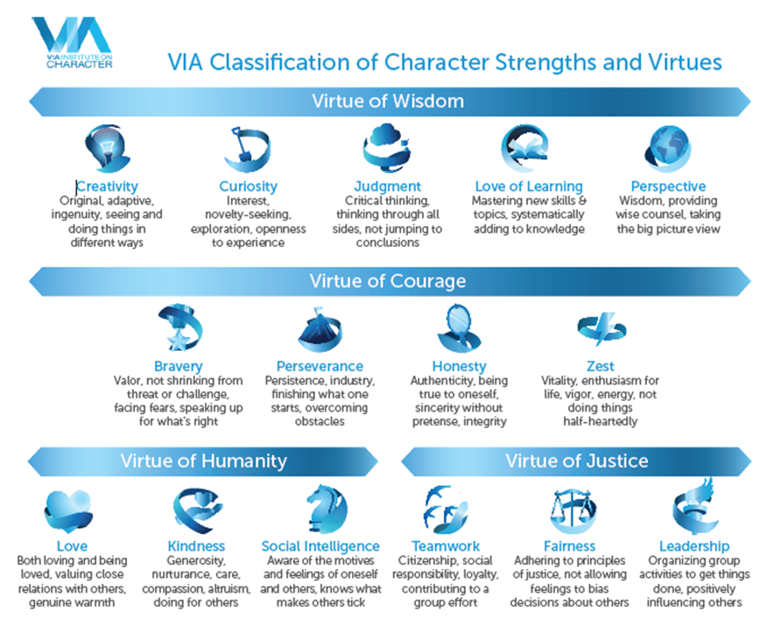

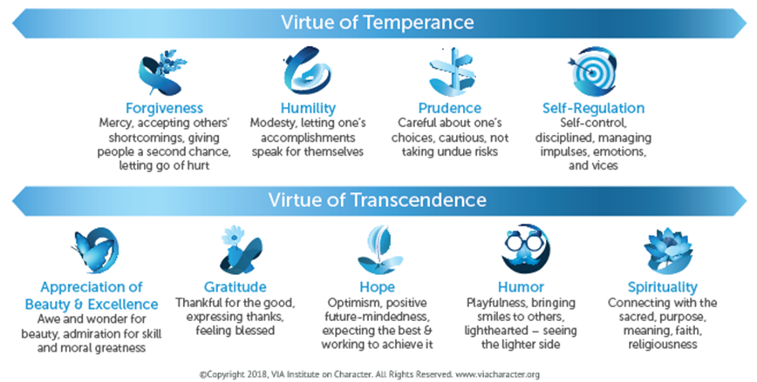
Learning About and Developing Your Character Strengths
- The Values in Action (VIA) Character Strengths Survey was created to help people to understand the relative order of their strengths and then use those strengths in new ways.
- The VIA uses immediate rank order results.
- It offers relative comparisons (i.e., comparison with oneself) rather than comparisons with others.
- The VIA survey is reliable (repeatable over time) and valid (accurately measures what it is supposed to measure).
- The VIA has been translated into 37 languages.
- Two short forms have been created with more studies being conducted to improve the measurement of character strengths.

To identify your character strengths:
- Navigate to: http://www.viacharacter.org/www/
- Create a username and password (your information will not be shared with commercial entities but will be deidentified and used for the purposes of research).
- Complete the VIA Character Strengths Inventory.
- Review your results.
- Consider ways to further develop your character strengths.

Two helpful resources include:
- Character strengths interventions: A field guide for practitioners.
- Positive psychology at the movies 2: Using films to build character strengths and well-being (2nd ed.).

Niemiec, R. M. (2018). Character strengths interventions: A field guide for practitioners. Boston, MA:
Holgrefe.
Niemiec, R. M., & Wedding, D. (2014). Positive psychology at the movies 2: Using films to build character
strengths and well-being (2nd ed.). Boston, MA: Holgrefe.

